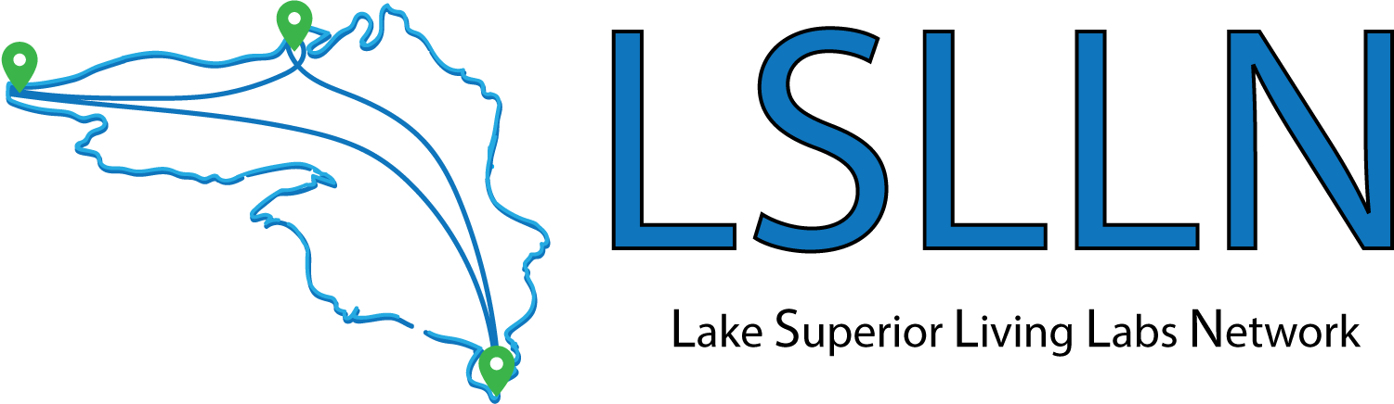

Annual Report
2019 - 2020

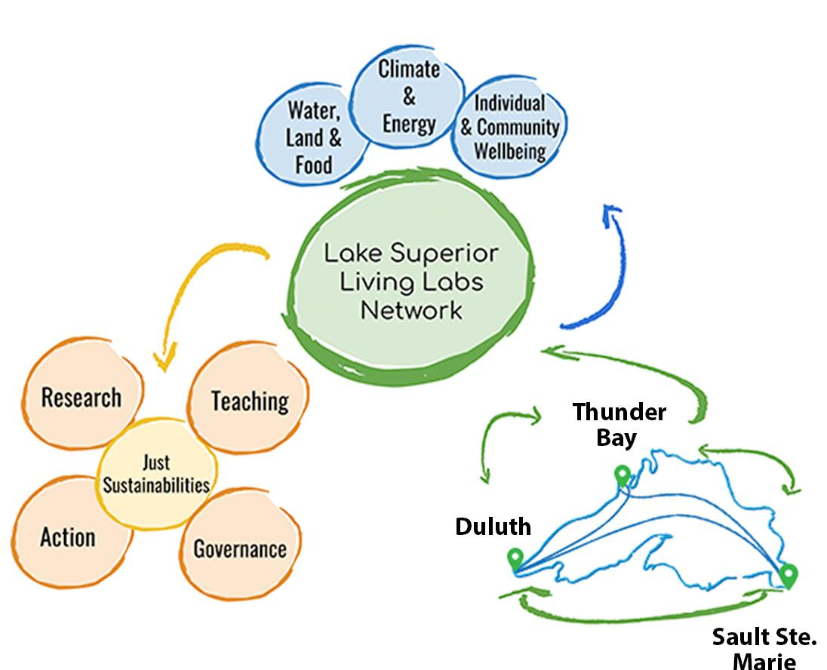

For information about this report or the Lake Superior Living Labs Network project contact
superiorlivinglabs@gmail.com or go to www.livinglabsnetwork.org.

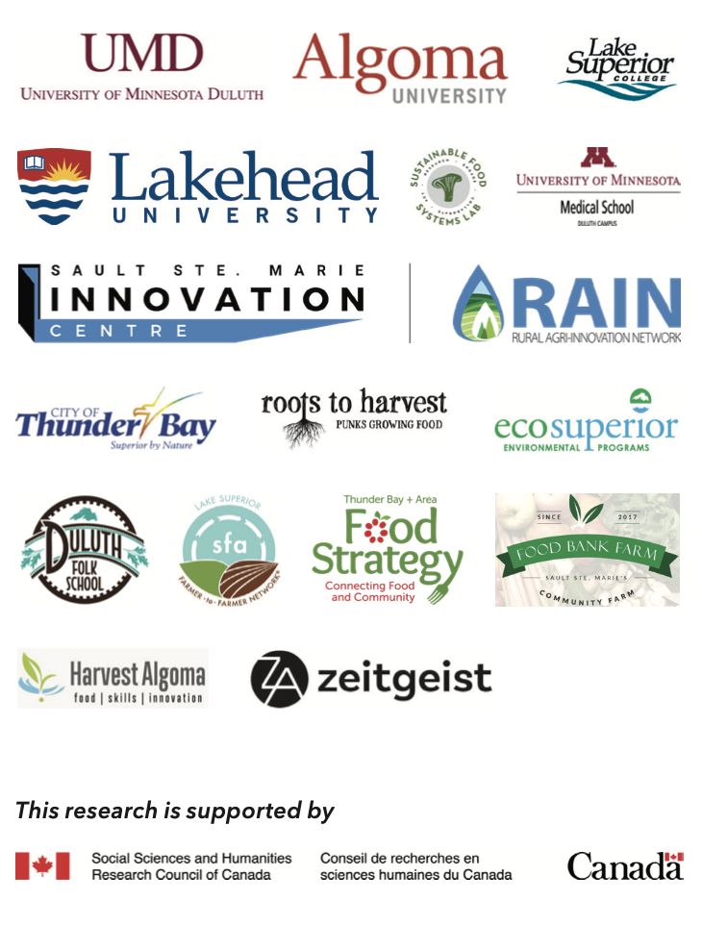

Table of Contents
1. Introduction 4
2. LSLLN Survey Findings 6
Lake Superior Living Labs Network Social Network Analysis 12
3. Network Wide Activities 14
Steering Committee Meetings 14
Website 14
Terms of Reference 14
Case Study Templates 15
Scoping Review 15
LSLLN Presentations 16
Activities/Events 16
Mini-Meet-Ups 17
Brochure 17
4. Hub Level Activities 18
Thunder Bay 18
Urban Access to Traditional Foods – Understanding Wild Game Event 19
Big Lake Reflections 19
Labyrinth Walk 19
Climate Change Communication Workshop 20
Seed Sovereignty Workshops 20
Blue Profound 20
Sustainability Stories Video Series 21
Sault Ste. Marie 21
Food Bank Farm Growth Facility 21
Indoor Growing Workshop 21
People’s Garden 21
Duluth 22
Blued Trees Symphony Project 22
The Lake Superior College Living Lab 22
Solar Commons 22
Superior Cooks Website 23
5. Budget 23
6. Looking Ahead 24

1. Introduction

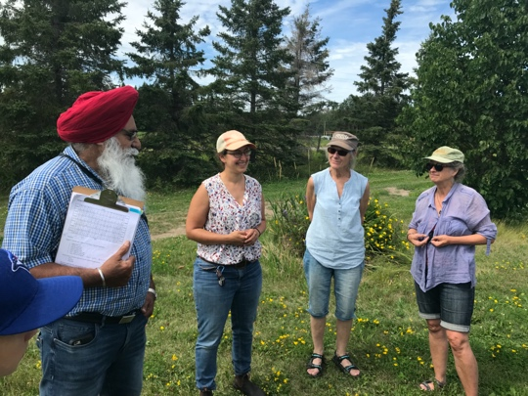
Ecological impacts of humans on the earth are the most pressing concerns of this generation. Issues such as climate change, soil degradation, water and air pollution, and deforestation have devastating effects on the social and ecological health of all life on the planet. Campus-community partnerships are well positioned to advance sustainability goals in the context of our rapidly changing world. Across the global north, universities and colleges are transforming their campuses into “living laboratories” that integrate research, teaching and community engagement to advance capacity for regenerative social-ecological systems. Living labs aim to co-create innovative solutions to sustainability challenges through interdisciplinary, placed-based experiential learning and community-engaged action in the built and natural environments.
Touring the Lakehead University Agricultural Research Station with the Agroecology and Seed Security project in Thunder Bay Ontario

The Lake Superior Living Labs Network (LSLLN) is based on a set of relationships among Lakehead University, the University of Minnesota Duluth, Lake Superior College, Algoma University and a number of non-profit organizations, businesses, First Nations and Tribal authorities across the Lake Superior watershed. The LSLLN is informed by calls for an integrated approach to address concerns at the nexus of water, food and land, climate and energy, and individual and community well-being. These collective efforts focus on increasing capacity for regenerative social-ecological systems across the Lake Superior watershed.

The LSLLN Objectives:

- Support and strengthen existing sustainability-related teaching, research and action initiatives on local, regional and watershed scales
- Connect three cross-national hubs through workshops and Sustainability Summits
- Experiment with tools and processes for learning and working together
- Strengthen existing partnerships between academic and community-based organizations
- Establish new collaborative projects
- Ensure equitable and meaningful long-term partnerships

While many across the Lake Superior watershed are already engaged in innovative projects, greater collaborations through the LSLLN will lead to more systematic and impacting solutions by sharing experiences and opportunities for synergistic just sustainable development.

In this annual report on our first year (2019-2020), we provide an overview of the key activities of the LSLLN and each of the three hubs.

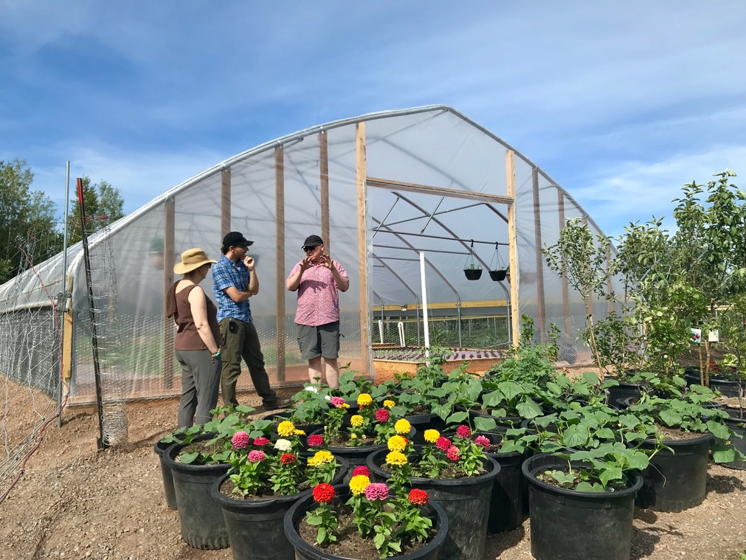
Lake Superior College Living Lab Farm, Duluth, MN

2. LSLLN Survey Findings

In 2019, the LSLLN launched a survey that ran from November 2019 to January 2020. The intention of the survey was to better understand the work happening within the LSLLN, to explore ways to support existing work, and to develop new collaborative projects across the Lake Superior watershed. Questions focused on collecting information about the member organizations, the strength of relationships between members, and experiences working on issues of social and ecological justice and sustainability. An invitation to participate in the survey was sent to 43 members and 38 individuals completed the survey.

The pages that follow are an overview of the survey results.

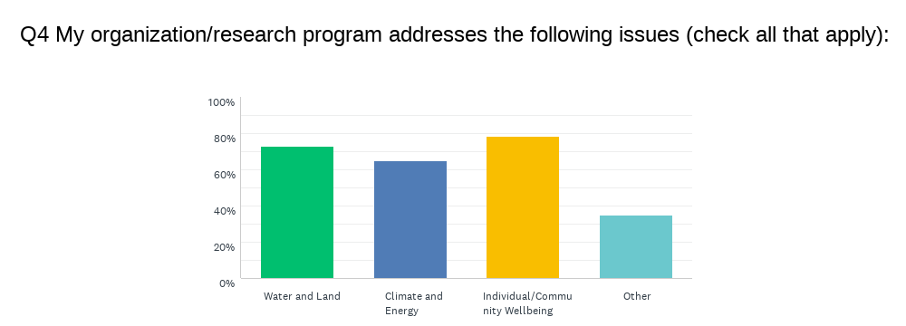

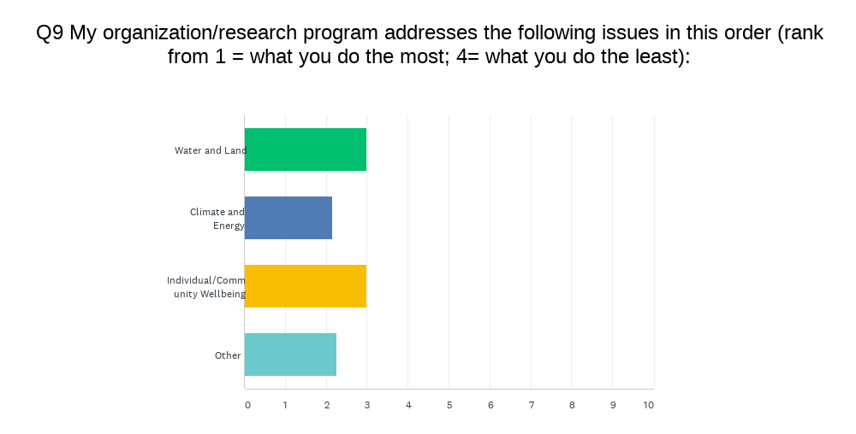
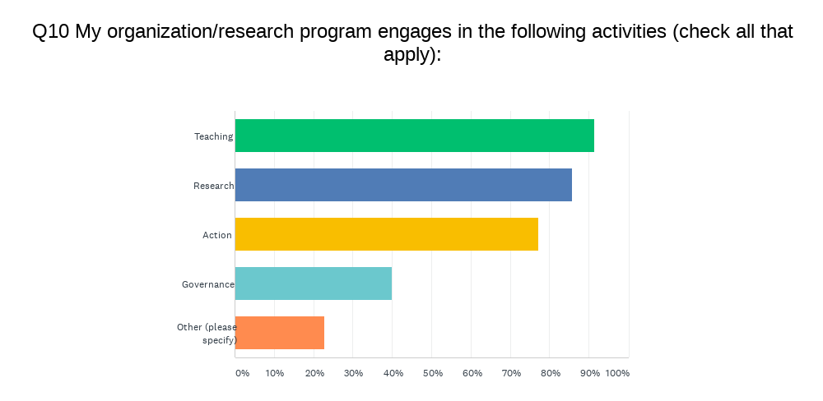
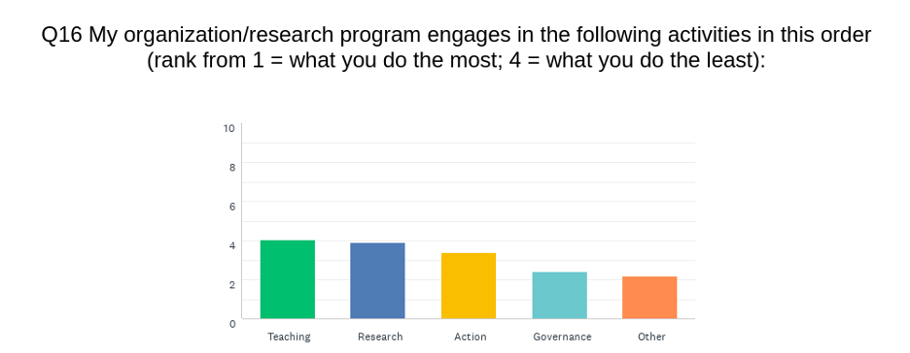

The following is an overview of respondent’s primary goals and objectives based on an open-ended question. The results are organized by theme (note: the numbers of responses are in brackets).

● Develop holistic community (5)
● Research
o Community based (5)
o Ecological (4)
o Interdisciplinary (3)
o Medical and health (3)
o Agricultural (2)
o New Technology (2)
o Food systems (2)
● Lower GHG emissions or lower climate impact (5)
● Educate and Prepare students (3 general statements)
o Small business (2)
o Agriculture (1)
o Cross-cultural (1)
● Engage the public (3)
● Promote sustainable food systems (4)
● Promote arts/craft (3)
● Promote Indigeneity (3)
● Provide basic needs
o Food (2)
o Housing (1)
● Commons ownership (1)
● Environmental governance (1)
● Grant support for research (1)

The following is an overview of the kinds of programs and initiatives from respondents. The results are organized by theme (note: the numbers of responses are in brackets).

● Governance (28)
● Develop sustainable food systems (28)
● Promote Indigenous Community/Resilience/Indigeneity (25)
● Academic Research (10)
o Climate Change (17)
o Aquatic ecosystems (11)
o Community based research (9)
o Indigenous (8)
o Food (6)
o Research Support (grant writing and reviewing applications; 5)
o Health and Medical (5)
o Governance and Policy (5)
o Place-Based (4)
o Air pollutants (2)
o Sustainable Agriculture (3)
● Academic Teaching (university-level; 5)
o Agriculture (13)
o Energy/Climate (8)
o Health (8)
o Env Ed (7)
o Cultural aspects (5)
o Business (5)
o Art (3)
o Geography (3)
o General work skills – not a course topic (3)
o Engineering (2)
o Indigenous (2)
o Social Justice (2)
● Education for the public/Community Engagement (15)
o Climate Change (16)
o Environmental and Sustainability (generally; 15)
o Art (12)
o Farming/Gardening (11)
o Indigenous worldview (7)
o Food Sovereignty (4)
o Active Transportation (4)
o Stormwater management (3)
o Cooking (2)
o Employment Skills (1)
● Host Professional Development Workshops
o Faculty Workshops (5)
o Farmer to Farmer (3)
● Implement Sustainability Plans - these might be the organizations themselves OR other organizations implementing a Municipal Sustainability Plan in their own work.
o University (6)
o Municipal (4)
● Promote Inclusivity (10)
● Promote Health (10)
● Promote Social Justice (8)
o Provide food (9)
o Provide housing (3)
o Provide safety from violence (2)
● Ecological/Environmental Protection (7)
o Climate change mitigation and adaptation (7)
o Fisheries (5)
o Stormwater management (2)
● Community Development (broadly; 5)
● Promote Local economy (5)

The following is an overview of the primary issues being addressed by respondents. The results are organized by theme (note: the numbers of responses are in brackets).

● Community sustainability (8)
● Health (8)
● Environmental degradation (broadly stated + air and soil protection; 8)
o Climate Change mitigation and adaptation (9)
o Contamination (2)
o Fisheries recovery (2)
o Aquatic pollution (2)
● Fighting systemic forces (5)
o Decolonization/Indigenous rights (10)
o Poverty (2)
o Social Injustice (stated by name; 5)
● Food-related
o Food security (by name; 6)
o Food Sovereignty (by name; 5)
o Agroecology (implied; 6)
o Food skills (implied; 3)
● Shifting consumer culture to value nature (4)
● Relationships (3)
● Rural Concerns (3)
● Sustainable Development (3)

The following is an overview of the policy issues being addressed by respondents. The results are organized by theme (note: the numbers of responses are in brackets).
● Food Policies (10)
● University-specific policies (8)
● Indigenous policies (7)
● Environmental policy (broadly stated; 6)
o Climate Change/Energy (9)
o Fisheries Management policies (2)
o Water Quality Policy (2)
● Human Rights (6)
● Health policies (5)
● Agriculture Policies (5)
● Economic policies (3)
● Arts Policies (2)
● Educational (2)
● Democratic Process Protection Policies (2 from same person)

The following is an overview of the key challenges being faced by respondents. The results are organized by theme (note: the numbers of responses are in brackets).

● Lack Funding – broadly stated (not specific to capital or long-term; 17)
o Lack Capacity (17)
o Insufficient Capital and/or Long-Term funding (8)
o Lack time (7)
o Lack transportation (1)
o Limited infrastructure (1)
● Lack Institutional Support for Sustainability (9)
● Partnerships are challenging (8)
● Corrupt Political Power (6)
o Settler Colonialism and Racism (5)
o Capitalism (3)
o Patriarchy (1)
● Recruitment and Engagement of people (farmers, industry, and “the public” were named specifically; 5)
● Competition (2)

Lake Superior Living Labs Network Social Network Analysis

As part of the survey, member organizations were asked to indicate their relationships with other member organizations in the LSLLN. Each respondent was asked to indicate the strength of their relationship (using on a four-point scale) based on communication, shared resources and joint programming and planning. Based on the data collected, a series of statistics and sociograms were created. These data will be helpful as we begin to assess relationships among the network partner organizations but also to compare as the network develops over the coming years. Below are a sample of the sociograms that were created based on this data.
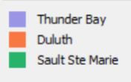
Node Legend - coloured by hub, size ranked by betweenness centrality
(Note: nodes are the circles in the diagrams that each represent one survey respondent)

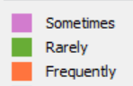
Edge Legend (coloured by frequency - rarely, sometimes, frequently)
(Note: edges are the lines between each node representing the strength of the relationship)

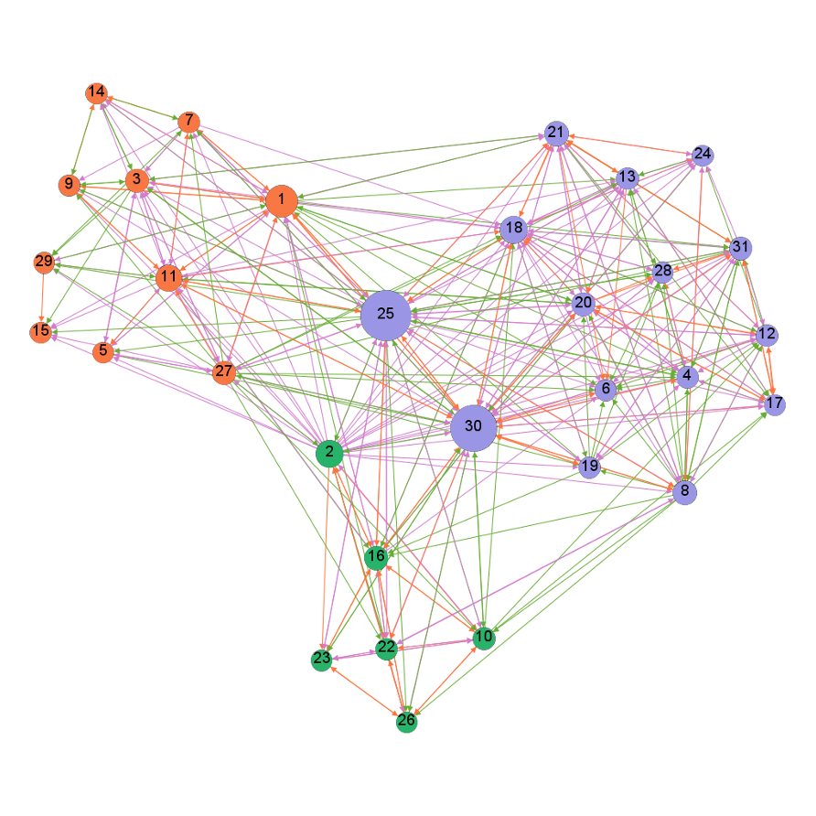

Communication Connections

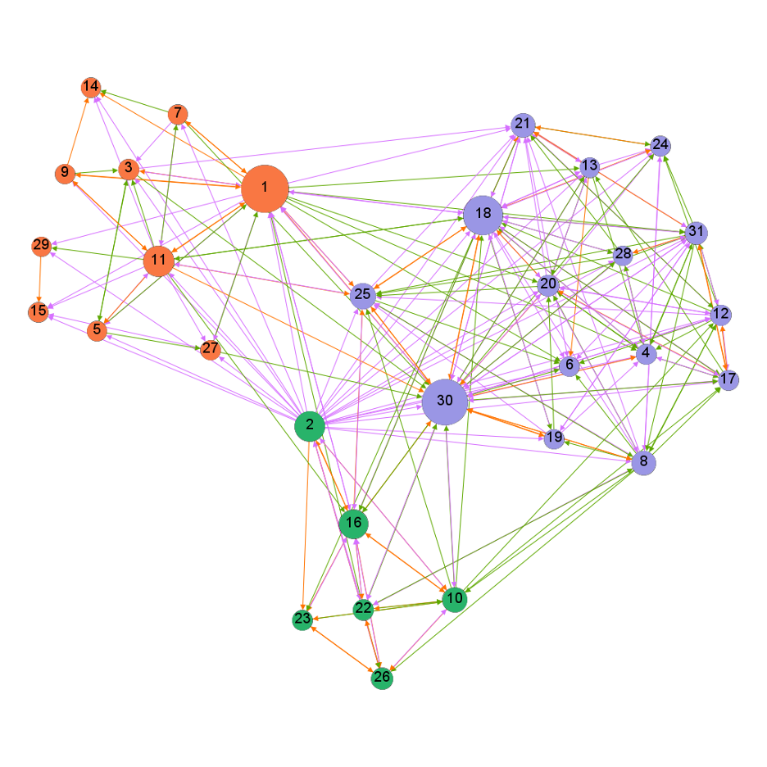
Shared Resource Connections

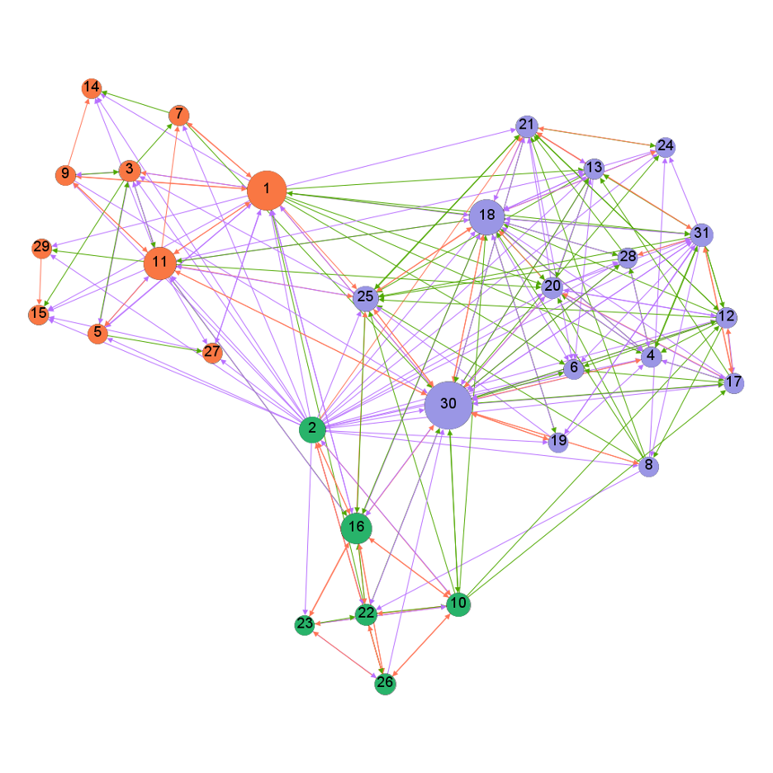
Joint Planning and Programming Connections

3. Network Wide Activities

Steering Committee Meetings
Steering Committee meetings took place approximately bi-monthly and included representatives from each of the hubs. At each meeting, Steering Committee members shared updates about the work taking place in their hub and discussed and planned future network wide activities.

Website
In summer 2019 a LSLLN website was launched. Since this time, the website is being regularly updated with event announcements, Mini Meet-Up details, project updates, new related videos, and other content. The website is a great resource for LSLLN members to learn about the work of others in the network. The website is: https://livinglabs.lakeheadu.ca/

Terms of Reference
The working LSLLN Terms of Reference was developed in Fall 2019 by the Steering Committee and LSLLN members provided feedback which was incorporated. The Terms of Reference outlines the goals of LSLLN, roles and responsibilities of the steering committee and members, and provides guidelines for overall governance. It is intended to be a living document, to grow and change with the network over time. The updated document is available on the LSLLN website.

Lake Superior Living Labs Network
Steering Committee
Thunder Bay
Hub Committee
Sault Ste. Marie
Hub Committee
Duluth
Hub Committee
University staff
Community partners
Students
Faculty
University staff
Community partners
Students
Faculty
University staff
Community partners
Students
Faculty

Case Study Templates
Case study templates were designed during the first year to gather information about the various Living Labs projects happening in the LSLLN. We had initial plans to disseminate these to LSLLN members in late spring. However, this has been delayed due to 1) COVID-19 which placed extra pressures on many LSLLN members and asking for another output in a stressful time did not seem necessary or appropriate, and 2) there was a sense among Hub Leads that the case studies would be more beneficial in the coming years when LSLLN relationships have had more time to develop. The template documents remain saved (and open to future edits), and the usefulness of them will be revisited in the next year or two.

Scoping Review
On November 21st, 2019 the Thunder Bay hub hosted a LSLLN workshop about scoping reviews. This workshop involved 20 people including LSLLN members from all three hubs and additional graduate students. The workshop focused on discussing the purpose and process of conducting scoping reviews, the plan to conduct a scoping review of the literature written about living labs, and consult with network members about the directions of this research and the research questions to examine.
Two key themes that emerged from workshop conversations were 1) the importance of relationships between network members, and 2) the importance of understanding the “who” and “how” questions through our scoping review (i.e. how do living labs help us move further towards our goals around just sustainabilities; how do living labs support co-creation?). Generally, workshop participants were interested in learning from what other people/groups/organizations (within and beyond the network) were doing, how they were doing it, and what was working. And relatedly, they were interested in exploring the best ways for sharing these experiences with one another. The scoping review process should contribute to this emerging collective desire from the group.
A working group will continue to move forward with the scoping review process. Next steps include: 1) finalizing the scoping review questions and search terms; 2) beginning the process of extracting and reviewing literature; and 3) analyzing the body of literature using a data extraction chart. The scoping review team will continue to consult with LSLLN members and share preliminary lessons that we are learning from the scoping review process. At the time of writing this report, the working group members were conducting data extraction and aim to analyse the data and co-write a manuscript during fall 2020.

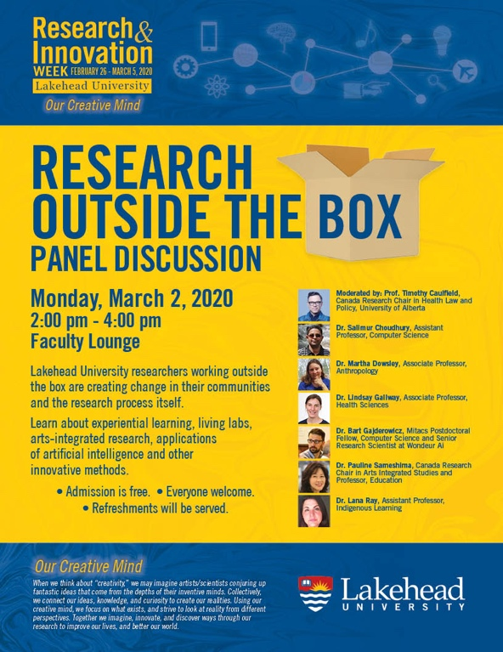
LSLLN Presentations
The following presentations about the LSLLN took place:
- Lakehead University Climate Change Symposium, Sept 2019
- Environment, Community, Health Observatory Network (ECHO), November 2019
- Lakehead University Research and Innovation Week, March 2019

There were a number of presentations planned for Spring 2019 that were canceled due to COVID19.

Activities/Events
Duluth Food Justice Meeting: In October, a group of LSLLN members attended the Minnesota Food Justice Summit in Duluth, MN. The event provided an opportunity to tour the LSLLN member American Indian Community Housing Organization (AICHO; left image) and the new Living Lab at Lake Superior College (right image). The conference provided active and engaging sessions (middle image) about food security, food justice, food sovereignty, and much inspiration. Duluth hub leads Randy Hanson and Kathryn Milun also hosted an evening for Thunder Bay visitors to meet and engage with Duluth LSLLN members.

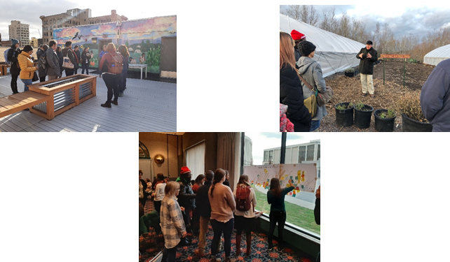

Mini-Meet-Ups

Mini-Meet-Ups were held to promote cross-network engagement, which represented activities that grew out of the expressed desire of many LSLLN members. Each mini Meet-Up featured an LSLLN member presenting one of their projects followed by an engaging discussion. These meetings were very well received and allowed for sharing our work and greater connection and communication. The sessions were open to all LSLLN members and lasted 45 minutes, hosted through the Zoom platform. The first four Mini-Meet-Ups were:

- Charles Levkoe and Kristen Lowitt (Thunder Bay Hub; February 2019) shared their community-engaged fisheries research with Batchewana First Nations
- Kathryn Milun (Duluth Hub; March 2020) discussed the Duluth Power Dialog event
- Laura Wyper (Sault Ste. Marie Hub; April 2020) presented on a research project connecting students to the Slow Food’s Ark of Taste
- Lindsay Galway (Thunder Bay Hub; May 2020) and Liz Esquega (Fort William First Nation) shared their research on climate change and health within the First Nation through arts informed inquiry.

The recording and resources from each presentation is available on the LSLLN website.

Brochure
During the fall 2019, the Steering Committee worked closely with Allen Lam (a graphic designer from Minneapolis) to develop an informational brochure for the LSLLN. The brochure is available for download on the LSLLN website and hard copies were sent to each of the hub leads in Thunder Bay, Sault Ste. Marie and Duluth. Please share these with your organizations and with other interested people and groups. We hope the brochure provides clarity and excitement about our goals for the LSLLN, and can be shared with member organizations and other interested people and groups.

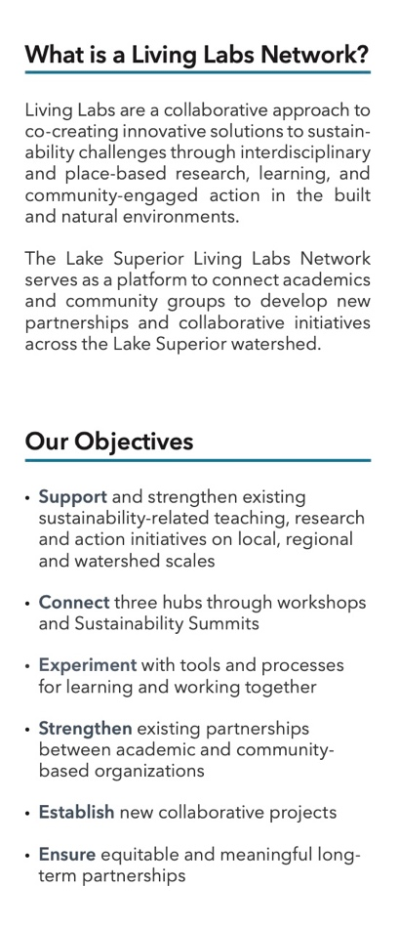
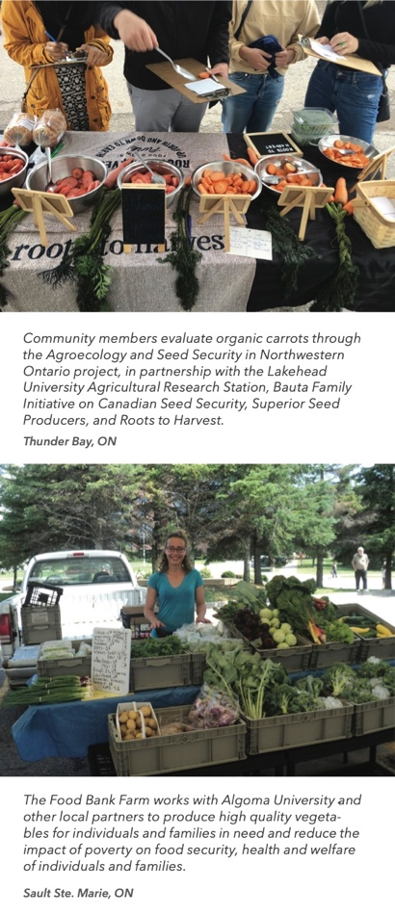
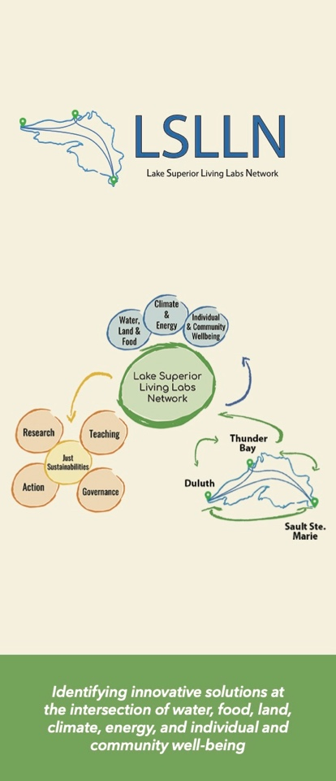

4. Hub Level Activities

Thunder Bay

The Thunder Bay hub included 19 members from Lakehead University and a number of organizations including EarthCare Thunder Bay, EcoSuperior, the Thunder Bay and Area Food Strategy, Roots to Harvest, and Brandon University in Manitoba. A core focus of the Thunder Bay hub’s first year has been building respectful and reciprocal relationships, that will support future collective work, learning from one another and sharing. In year two of the project, the Thunder Bay Hub will work towards identifying a collaborative project that we will engage in together.

Hub members led and/or participated in the following activities:

Urban Access to Traditional Foods – Understanding Wild Game Event
This event was held on October 29 and 30, 2019 and hosted in partnership with the Indigenous Food Circle and the Thunder Bay District Health Unit’s Understanding Our Food Systems project. The Urban Access to Traditional Foods – Understanding Wild Game event in Thunder Bay. LSLLN members Karen Kerk (Thunder Bay and Area Food Strategy) and Charles Levkoe (Lakehead University) were actively involved in the planning and coordination of the event which provided sessions by the Thunder Bay Health Unit, Sustain Ontario: The Alliance for healthy Food and Farming, Meno Ya Win Health Centre, Nourish, and Chef Rich Francis. The food was delicious and the discussion on the legality of serving wild game in urban settings was fruitful. A documentary about wild game was developed by the team and can be viewed on the Understanding Our Food Systems website.

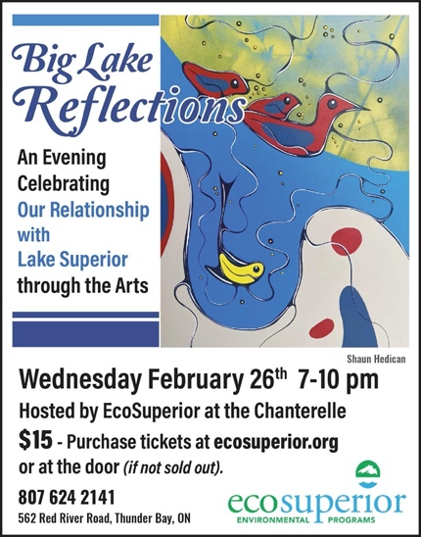
Big Lake Reflections
On February 26th, 2020, EcoSuperior hosted Big Lake Reflections: A celebration of our relationship with Lake Superior through the Arts. One of the intentions, was to help inspire a stronger commitment to being stewards, and to deepen our commitment to protecting the freshwater of Lake Superior. The evening was about connections, relations, and beauty. There were 15+ local talented artists - representing a diversity of art modalities, including singer songwriters, painters, stone carver, dancer, poet, photographers, fiber artists, and more. Over 200 attendees enjoyed food from local establishments and food artisans and a Lake Superior themed cocktail the Blue Spruce Mojito.

Labyrinth Walk
In February 2020, one of the Thunder Bay hub meeting included a facilitated walk through a labyrinth where, together, we reflected on the questions: 1) What do we need from the emerging LSLLN collaborative to sustain our journey?; and, 2) What can we imagine creating together? After the walk, these ideas were shared with the group. We also wondered: what is already coming into form at this time that deserves our collective notice? In May, the hub members revisited the core themes that emerged from the labyrinth walk.

As part of a long-term pan-university project for wellbeing, Lakehead University is building a permanent outdoor labyrinth this summer or fall. Dubbed "The Wellness Path," the aim of the project is to create a dedicated space for renewal, a human refugium, that is accessible for everyone in the Thunder Bay community.

Climate Change Communication Workshop
Many LSLLN members attended this event right before COVID-19 cancelled in-person events. It was hosted by Aynsley Klassen (EcoSuperior) in collaboration with Lindsay Galway (Lakehead University).

Seed Sovereignty Workshops
In August 2019, a Seed Sovereignty event was held in partnership with Roots to Harvest and Superior Seed Producers to share seed saving techniques. Through spring and summer 2020, Rachel Portinga (Lakehead University) worked with Roots to Harvest on a community-based research project focusing on seed security, climate change, health and well-being, and resilience in addition to hosting gardening and seed saving workshops which are available on the Roots to Harvest website. This project is a partnership funded through the Lakehead University Agricultural Research Station (LUARS) Agricultural Research Capacity Development Program Grant Awarded by the Office of the Vice President, Research and Innovation.

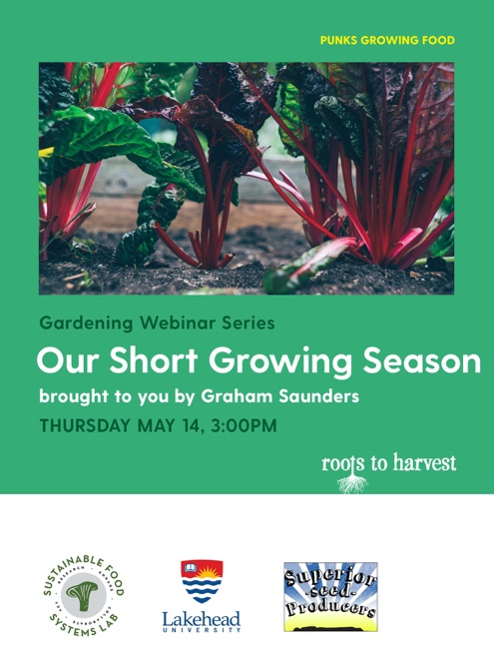
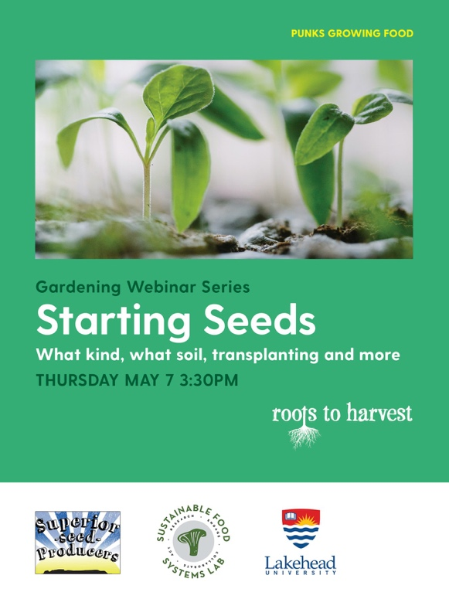

Blue Profound
This emerging project was sparked from the Big Lake Reflections event and is being co-created by LSLLN members at Lakehead University and EcoSuperior (and others at Lakehead University). The concept is to create a Coffee Table Book to deepen collective ties to Lake Superior with deep listening across time and genres.

Sustainability Stories Video Series
The Thunder Bay hub has started to work on its first hub-wide project – “Sustainability Stories”. This collaboration will produce a series of videos that illustrate and share various projects, partnerships and ideas happening within the Thunder Bay hub, and the people who do the work. The videos will integrate elements of just sustainability and the core themes of the LSLLN. There is potential for the video project to be used in other hubs to help share our work across the network. We hired a Lakehead student to film and craft the videos; based on a group decision to use some of our funds to support this project.

Sault Ste. Marie
The Sault Ste Marie hub had six members the represented Algoma University, Shingwauk Residential Schools Centre, the People’s Garden, Food Bank Farm, RAIN (Rural Agri-Innovation Network), and Harvest Algoma (a division of United Way of Sault Ste Marie and Algoma District).

Hub members led and/or participated in the following activities:

Food Bank Farm Growth Facility
The Food Bank Farm has constructed a growth facility within a shipping container. It is currently being tested and it is expected to produce select vegetables and lettuce year-round during regular operations.

Indoor Growing Workshop
On April 2nd, 2020, the People’s Garden hosted a virtual Indoor Growing Workshop, promoted by LSLLN Hub members and supported by Algoma University Student Union. This workshop included information about proper growing practices for microgreens, herb growing and salad greens. Attendees learned about different types of containers, what containers work best for which plants, fertilizers and pesticides, seedlings, how to extend harvests and increase yields! The workshop was taught by Cheyenne Sundance, a self-taught organic farmer who has worked in both rural and urban settings. Cheyenne is founder and farmer of Sundance Harvest, which is a urban farm in Toronto, Ontario that focuses on food justice and eradicating systemic racism in the food system. Cheyenne is also a member and creator of Toronto's first Urban Farm Coop, Radical Roots. The LSLLN SSM hub members helped to promote this event in their region.

People’s Garden
Despite the impacts of COVID-19, members of the Sault Ste. Marie Hub were able to grow in the People’s Garden again this year. It is a community garden on the campus of Algoma University.

Duluth
The Duluth hub had fourteen members representing Lake Superior College, the University of Minnesota Duluth, Zeitgeist Arts, the Lake Superior Sustainable Farming Association (LSSFA), the City of Duluth, the American Indian Community Housing Organization (AICHO), and the Duluth Folk School.

Hub members led and/or participated in the following activities:

Blued Trees Symphony Project
The Blued Trees Symphony Project is taking up the invitation of indigenous peoples from Honor the Earth to protect our water by bringing a Canadian inspired art copyright technique to work in our local watershed. An interdisciplinary team of UMD researchers and students created a GIS map of local watershed areas under potential impact from oil and gas pipeline expansion. Researchers created a partnership with the New York-based artist, Aviva Rahmani, who owns the copyright on the Blued Trees Symphony. Working with Ms Rahmani, the group contacted and interviewed local Lake Superior watershed property owners and settled on a site for art-activity. The painting process, planned for Earth Day, was unfortunately interrupted by COVID-19. Researchers and community members will reengage the project in the Fall of 2020.

The Lake Superior College Living Lab
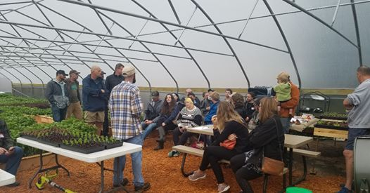
The LSC Living Lab is the field site for the Eco-Entrepreneurship Program at Lake Superior College. The LSC Living Lab, launched in Spring, 2019, will be iteratively (re)built over the next years as projects and collaborators evolve while it serves as the experiential campus/community laboratory for the transformational work we are engaging. It will also be adding renewable energy and value-added processing emphases and experiential learning sites shortly to our program.

Solar Commons
The Solar Commons Project, now housed at the Minnesota Design Center on the University of Minnesota Twin Cities campus, is working with community partners in Virginia, MN to see if community trust-owned solar arrays can be managed as Solar Commons that generate a stable revenue stream to support job-training programs for low-income residents in Virginia's expanding project to relocalize food production. Like many places, Virginia is experiencing the pandemic's disruption of its food chains; food banks suddenly need to serve many more residents. The fragility of the food system serving the Northland is abruptly apparent. Community members who have been building Virginia's food forest and community gardens are now looking into whether their parallel interests in transitioning to clean energy can become an economic development tool to grow Virginia's food hub. Solar Commons Project researchers assisted community partners in mapping rooftops and ground sites for solar capacity, calculating the revenue stream from electricity savings, and designing a trust agreement that would maximize the sun's commonwealth by funding strategic nodes in Virginia's expanding local food economy: repairing a shuttered main street restaurant to be a community kitchen; teaching community gardening, foraging, preserving; helping residents learn entrepreneurial skills to sell food to their neighbors on the Iron Range. As a "living lab" project, the Virginia Solar Commons prototype would be studied to demonstrate the "commons" value of community trust solar ownership in the Lake Superior watershed: local, clean energy whose value was fully captured and locally circulated as common wealth to generate healthier, more equitable and sustainable regional food chains. Memoranda of agreement have been signed with all local parties including the Solar Commons site host to create the trust agreement. In fall of 2020, Minnesota Design Center researchers will begin fundraising efforts to build the proposed 500kW solar array and co-create the local governance platform.

The Duluth Hub is also the site of a collaboration with the Solar Commons Project and the American Indian Community Housing Organization (AICHO) which has created a process to bring artists into the messaging for Solar Commons. Kathryn Milun is working with AICHO to produce an Indigenous-perspective "translation" of the gathering rights of Solar Commoners and the reciprocity guidelines in Solar Commons trusts (which are designed to empower underserved communities through regenerative social-ecological systems).

Duluth Power Dialog
UMD students planned a community conversation event on local clean energy transition to be held at another LSLLN partner, Zeitgeist Community Theater. UMD researchers raised funds so that students could host this public event and invite a speaker from impacted Canadian First Nations. Panelists included representatives of Minnesota’s Citizen’s Utility Board and members of the Theater for Public Policy. Sadly, the event was postponed because of the pandemic but rescheduled for Spring 2021.

Superior Cooks Website
Randy Hanson and the Lake Superior Sustainable Farming Association have been working on creating a Superior Cooks website to connect growers and eaters about foods and cooking them within the Lake Superior watershed. The website can be located at https://www.rootsandrecipes.org/

5. Budget
The initial phase of the LSLLN is been funded by a grant from the Social Science and Humanities Research Council of Canada (2019–2022). The budget was originally conceived as follows.

Algoma University
Budget Item | Year 1 | Year 2 | Year 3
Students (graduate and undergraduate) | $5,000 | $5,000 | $5000
Community Partners (salary allowance) | $5000 | $5000 | $5000
Research Related Travel | $1500 | $1500 | $1500
Knowledge Mobilization Related Travel | $2200 | $600 | $2200
Program Committee Meetings | $1000 | $1000 | $1000
Workshops | $1500 | $1500 | $1500
Sustainability Summit |  | $2000
Computer Equipment | $2702

University of Minnesota Duluth
Budget Item | Year 1 | Year 2 | Year 3
Students (graduate and undergraduate) | $2,500 | $2,500 | $2,500
Community Partners | $2,500 | $2,500 | $2,500
Research Related Travel | $750 | $750 | $750
Knowledge Mobilization Related Travel | $300 | $1100 | $1100
Program Committee Meetings | $500 | $500 | $500
Workshops | $750 | $750 | $750
Sustainability Summit | $1000
Computer Equipment | $1351

Lake Superior College
Budget Item | Year 1 | Year 2 | Year 3
Students (graduate and undergraduate) | $2,500 | $2,500 | $2,500
Community Partners | $2,500 | $2,500 | $2,500
Research Related Travel | $750 | $750 | $750
Knowledge Mobilization Related Travel | $300 | $1100 | $1100
Program Committee Meetings | $500 | $500 | $500
Workshops | $750 | $750 | $750
Sustainability Summit | $1000
Computer Equipment | $1351

Lakehead University
Budget Item | Year 1 | Year 2 | Year 3
Students (graduate and undergraduate) | $5,000 | $5,000 | $5000
Community Partners | $5000 | $5000 | $5000
Research Related Travel | $1500 | $1500 | $1500
Knowledge Mobilization Related Travel | $2200 | $600 | $2200
Program Committee Meetings | $1000 | $1000 | $1000
Workshops | $1500 | $1500 | $1500
Sustainability Summit |  | $2000
Computer Equipment | $2702

6. Looking Ahead
Over the coming year we aim to engage in the following activities:

- Engage in networking and relationship building
- Develop a series of profiles to highlight examples of teaching, research and action initiatives taking place at each hub
- Identify common concerns and opportunities
- Hold at least three workshops relevant to network members
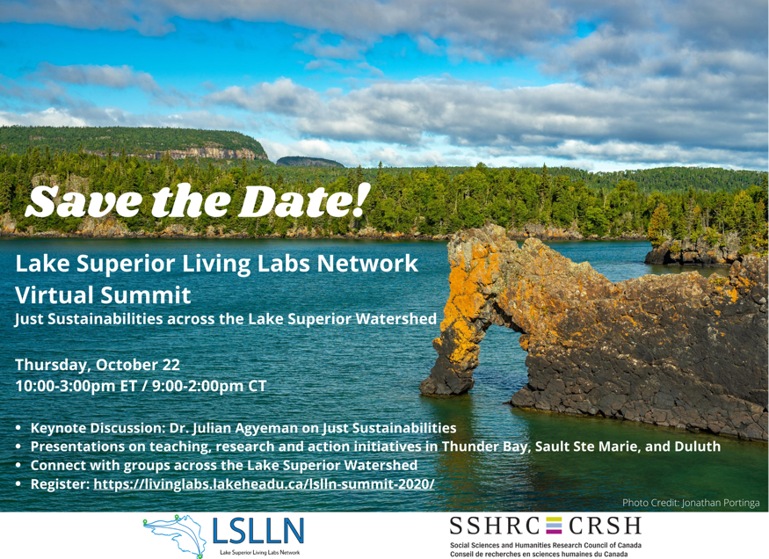
- Identify new partners to engage as part of the network
- Develop field school/course curriculum
- Develop and pilot new collaborative projects
- Host the first Lake Superior Sustainability Summit (will be online due to COVID-related restrictions)

